Acceptance Test Data Sheets

For

Skyryse Flight OS LEMA TPX 325

|  |  |
| --- | --- |
| LEMA Assembly Part Number | Serial Number |
|  | 12 |

6.1. **Visual Examination of the Product**

|  |  |
| --- | --- |
| UUT conforms to the requirements of paragraph 6.1 | True |

6.2 **Weight**

|  |  |
| --- | --- |
| UUT weight should not exceed 10 lbs | actual weight 8.2 lbs |

**6.3 Bonding Do we need a pass fail column on these tables? ‘Comparision’ is in TDMS**

Bonding resistance

|  |  |  |  |  |
| --- | --- | --- | --- | --- |
|  | **Expected** | **Tolerance** | **Simplex** | **Duplex** |
|  | (mOhms) | (mOhms) | (mOhms) | (mOhms) |
| Motor End Cap | 2.5 mOhms | 0.5 mOhms | 2 mOhms | 1 mOhms |
| Solenoid housing | 2.5 mOhms | 0.5 mOhms | 3 mOhms | 2 mOhms |
| Encoder cover | 2.5 mOhms | 0.5 mOhms | 2 mOhms | 2 mOhms |

6.4 Resistance and Inductance Test (motor and solenoid)

**Resistances:**

|  |  |  |  |  |  |
| --- | --- | --- | --- | --- | --- |
|  | **Expected** | **Tolerance** | **Connector J1** | **Connector J2** | **Connector J3** |
| Pins | Resistance (Ohms) | Resistance (Ohms) | Resistance (Ohms) | Resistance (Ohms) | Resistance (Ohms) |
| E to F | 0.212 mOhms | 0.0212 Ohms | 1 Ohms | 0 Ohms | 0 Ohms |
| F to G | 0.212 mOhms | 0.0212 Ohms | 1 Ohms | 0 Ohms | 0 Ohms |
| G to E | 0.212 mOhms | 0.0212 Ohms | 0 Ohms | 0 Ohms | 0 Ohms |
| A to L | 6.55 mOhms | 0.44 Ohms | 0 Ohms | 0 Ohms | 1 Ohms |
| G,F,E,A,L tied together to chassis grounds. Apply 500VDC | 5000000 mOhms | 0 Ohms | 0 Ohms | 0 Ohms | 1E+7 Ohms |

**Inductances:**

|  |  |  |  |  |  |  |
| --- | --- | --- | --- | --- | --- | --- |
|  | | **Expected** | **Tolerance** | **Connector J1** | **Connector J2** | **Connector J3** |
|  | | Inductance  (mH) | Inductance  (mH) | Inductance  (mH) | Inductance  (mH) | Inductance  (mH) |
| E to F | 0.155 mH | | 0.02325 mH | 0 mH | 0 mH | 0 mH |
| F to G | 0.155 mH | | 0.02325 mH | 0 mH | 0 mH | 0 mH |
| G to E | 0.155 mH | | 0.02325 mH | 0 mH | 1 mH | 0 mH |
| A to L | 22 mH | | 3.3 mH | 0 mH | 0 mH | 0 mH |

6.5 **Power ON UUT Checks**

Confirm all sensors are reporting nominal values and no faults reported

|  |  |  |
| --- | --- | --- |
| Sensor | Value | Pass/Fail |
| Motor 1 | -0.0062 | Pass |
| Motor 2 | -0.0005 | Pass |
| Motor 3 | 0.0004 | Pass |
| M1 | 0 | Pass |
| M2 | 0 | Pass |
| M3 | 0 | Pass |
| Faults 1 | 0 | Failed |
| Faults 2 | 0 | Failed |
| Faults 3 | 0 | Failed |

6.6 **Functional Check Out**

6.6.1 **MCE1, MCE 2, MCE3 Power Up**

|  |  |  |  |
| --- | --- | --- | --- |
| Description | Ballnut position | Pass/Fail | |
| MCE 1 reports values for Ballnut position and motor current | 0 | Ballnut Position | Current |
| Pass | Unhandled Type: Void |
| (Simulated) FCC/reports values for M1(QPS) | 1 | Pass |  |
| MCE 2 reports values for Ballnut position and motor current | 0 | Pass | Unhandled Type: Void |
| (Simulated) FCC/reports values for M2(QPS) | -2 | Pass |  |
| MCE 3 reports values for Ballnut position and motor current | 0.0002 | Pass | Unhandled Type: Void |
| (Simulated) FCC/reports values for M3(QPS) | 1 | Pass |  |

6.7.2 **N1 and N2 Extend Mechanical Stops and MCE Rigging**

**CALIBRATION ADDITON TO MCE (NEW)**

**Step 6.7.2.1** **Extend using M1/N1**

|  |  |  |
| --- | --- | --- |
| Description | Value | Pass/Fail |
| N1 extend stop engaged (M1 current saturated) | 1024 | Pass |
| MCE 1 Motor Current 4.5 +/- 0.15 Amps | 5.9873 Amps | Failed |
| Linear Encoder Value | 0.0512 | Pass |
| N1 is Rigged | 0 | Pass |

**Step 6.7.2.2** **Extend using M2/N2**

|  |  |  |
| --- | --- | --- |
| Description | Value | Pass/Fail |
| N2 extend stop engaged (M2 current saturated) | 1024 | Pass |
| MCE2 Motor Current 4.5 +/- 0.15 Amps | 6.0053 Amps | Failed |
| Linear Encoder Value | 0.1236 | Pass |
| N2 (Motor 2) is Rigged | 0 | Pass |
| N2 (Motor 3) is Rigged | 0 | Pass |

6.7.3 **N1 and N2 Stroke Check**

|  |  |  |
| --- | --- | --- |
| Pin to pin Length is 16.732 +/- TBD (ins) | Pin to Pin Length | Pass/Fail |
|  |  |
| Description | Actual Position N1/N2 | Pass/Fail |
| N2 at -0.575 ins from Null using M2 | -0.575 | Pass |
| N1 at +1.725 ins from Null using M1 | 1.725 | Pass |
| N1 at -0.575 ins from Null using M1 | -0.575 | Pass |
| N2 at +1.725 ins from NULL using M2 | 1.725 | Pass |
| N1 at -0.575 ins from Null using M1 | -0.5751 | Pass |
| N2 at +1.725 ins from Null using M3 | 1.7243 | Pass |
| N2 at -0.575 ins from Null using M3 | -0.5725 | Pass |

MOTOR 1

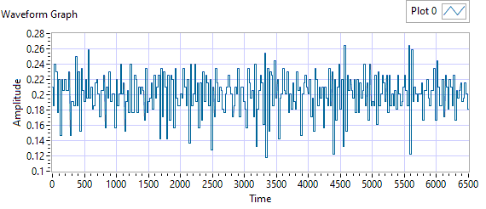

Figure - Ballnut Velocity for Motor One

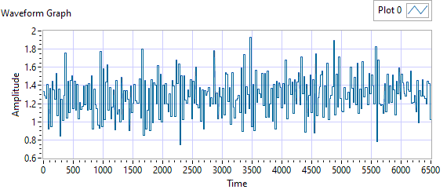

Figure -Current for Motor One

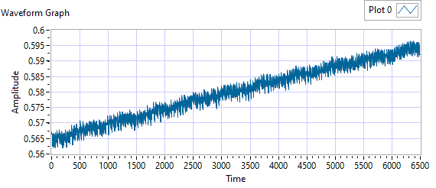

Figure - M1 Delta for Motor One

|  |  |  |  |  |  |
| --- | --- | --- | --- | --- | --- |
| **Description** | **Expected** | **Tolerance** | **Actual Average** | **Peak Velocity** | **Pass/Fail** |
| Constant Velocity | 0.2 | 0.02 | 0.2006 | 0.2643 | Failed |
| **Description** | **Expected** | **Tolerance** | **Actual** | **Standard Deviation** | **Pass/Fail** |
| Delta between Motor 1 Position and M1 position | 0.1 | 0.2 | 1.5964 | 0.0088 | Failed |
| Delta between Motor 1 Position and Linear Encoder position | 0.1 | 0.2 | 0.5966 | 0.3751 | Failed |
| Motor Current |  |  | 1.2892 | 0.2165 |  |

|  |  |  |  |  |
| --- | --- | --- | --- | --- |
| Description | Expected Difference from Test rig encoder | Tolerance | Difference from Test rig encoder | Pass/Fail |
| Motor 1 position + Motor 2 position = test rig encoder | 0 | 0.1 | 0.005 | Pass |
| Motor1 position + Motor 3 position = test rig encoder | 0 | 0.1 | 0.005 | Pass |
| M1 position + M2 position = test rig encoder | 0.1 | 0.1 | -0.3687 | Failed |
| M1 position + M3 position = test rig encoder | 0 | 0.1 | -0.3687 | Failed |
| Difference between Motor 2 position and Motor 3 position is < TBD ins | 0 | 0.1 | 0 | Pass |
| Difference between M2 position and M3 position is < TBD ins | 0 | 0 | 0 | Pass |
| Difference between Motor 1 position and M1 position is < TBD ins | 0 | 0.1 | 0.9487 | Failed |
| Difference between Motor 2 position and M2 position is < TBD ins | 0 | 0.1 | 0.575 | Failed |
| Difference between Motor 3 position and M3 position is < TBD ins | 0 | 0.1 | 0.575 | Failed |

MOTOR 2

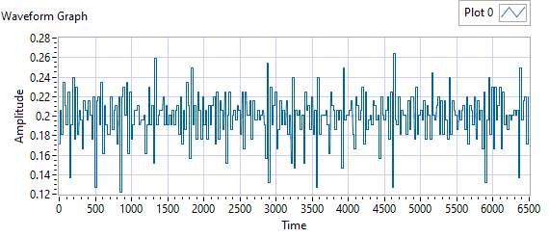

Figure - Ballnut Velocity for Motor Two

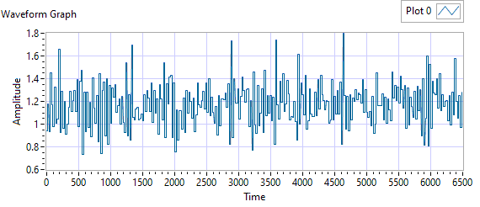

Figure -Current for Motor Two

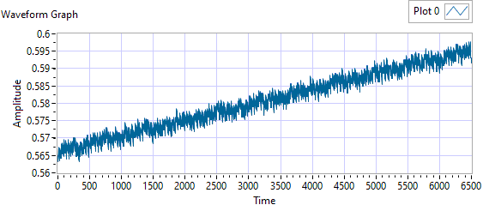

Figure - M1 Delta for Motor Two

|  |  |  |  |  |  |
| --- | --- | --- | --- | --- | --- |
| **Description** | **Expected** | **Tolerance** | **Actual Average** | **Peak Velocity** | **Pass/Fail** |
| Constant Velocity | 0.2 | 0.02 | 0.1992 | 0.2643 | Failed |
| **Description** | **Expected** | **Tolerance** | **Actual** | **Standard Deviation** | **Pass/Fail** |
| Delta between Motor 2 Position and M2 position | 0.1 | 0.2 | 1.5976 | 0.0083 | Failed |
| Delta between Motor 2 Position and Linear Encoder position | 0.1 | 0.2 | 0.5971 | 0.3749 | Failed |
| Motor Current |  |  | 1.1739 | 0.1878 |  |

|  |  |  |  |  |
| --- | --- | --- | --- | --- |
| Description | Expected Difference from Test rig encoder | Tolerance | Difference from Test rig encoder | Pass/Fail |
| Motor 1 position + Motor 2 position = test rig encoder | 0 | 0.1 | 0.0055 | Pass |
| Motor1 position + Motor 3 position = test rig encoder | 0 | 0.1 | 0.0056 | Pass |
| M1 position + M2 position = test rig encoder | 0.1 | 0.1 | -0.3578 | Failed |
| M1 position + M3 position = test rig encoder | 0 | 0.1 | -0.3578 | Failed |
| Difference between Motor 2 position and Motor 3 position is < TBD ins | 0 | 0.1 | 0.0014 | Pass |
| Difference between M2 position and M3 position is < TBD ins | 0 | 0 | 0 | Pass |
| Difference between Motor 1 position and M1 position is < TBD ins | 0 | 0.1 | 0.575 | Failed |
| Difference between Motor 2 position and M2 position is < TBD ins | 0 | 0.1 | 0.9383 | Failed |
| Difference between Motor 3 position and M3 position is < TBD ins | 0 | 0.1 | 0.9384 | Failed |

MOTOR 3

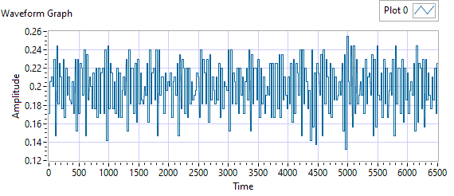

Figure - Ballnut Velocity for Motor Three

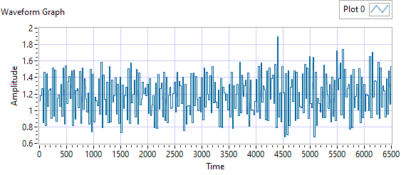

Figure -Current for Motor Three



Figure - M3 Delta for Motor Three

|  |  |  |  |  |  |
| --- | --- | --- | --- | --- | --- |
| **Description** | **Expected** | **Tolerance** | **Actual Average** | **Peak Velocity** | **Pass/Fail** |
| Constant Velocity | 0.2 | 0.02 | 0.1995 | 0.2545 | Failed |
| **Description** | **Expected** | **Tolerance** | **Actual** | **Standard Deviation** | **Pass/Fail** |
| Delta between Motor 3 Position and M3 position | 0.1 | 0.2 | 1.5864 | 0.0086 | Failed |
| Delta between Motor 3 Position and Linear Encoder position | 0.1 | 0.2 | 0.5979 | 0.3752 | Failed |
| Motor Current |  |  | 1.1808 | 0.2503 |  |

|  |  |  |  |  |
| --- | --- | --- | --- | --- |
| Description | Expected Difference from Test rig encoder | Tolerance | Difference from Test rig encoder | Pass/Fail |
| Motor 1 position + Motor 2 position = test rig encoder | 0 | 0.1 | 0.0055 | Pass |
| Motor1 position + Motor 3 position = test rig encoder | 0 | 0.1 | 0.0055 | Pass |
| M1 position + M2 position = test rig encoder | 0.1 | 0.1 | -0.3699 | Failed |
| M1 position + M3 position = test rig encoder | 0 | 0.1 | -0.3699 | Failed |
| Difference between Motor 2 position and Motor 3 position is < TBD ins | 0 | 0.1 | 0.0012 | Pass |
| Difference between M2 position and M3 position is < TBD ins | 0 | 0 | 0 | Pass |
| Difference between Motor 1 position and M1 position is < TBD ins | 0 | 0.1 | 0.575 | Failed |
| Difference between Motor 2 position and M2 position is < TBD ins | 0 | 0.1 | 0.9504 | Failed |
| Difference between Motor 3 position and M3 position is < TBD ins | 0 | 0.1 | 0.9504 | Failed |

**6.7.4 Brake Release Test**

**Step d –** LEMA reaches commanded position

|  |  |  |  |  |
| --- | --- | --- | --- | --- |
| Description | Expected | Tolerance | Position | Pass/Fail |
| MCE1 /Motor 1 | 0.2 |  | 0.1802 | Pass |
| MCE2 /Motor 2 | 0.2 |  | 0.1854 | Pass |
| MCE3 /Motor 3 | 0.2 |  | 0.1881 | Pass |

**6.7.5 Performance Test – unloaded operation (one channel operation)**

**6.7.5.1.1 MCE 1 - Step Response Test**

**The result for motor one is shown below:**

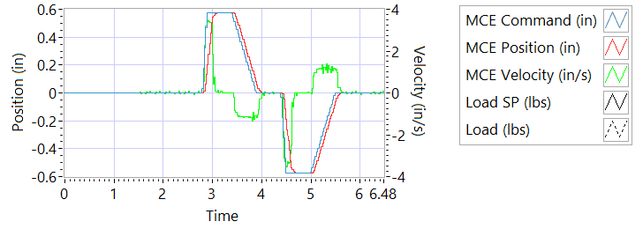

Figure - Results for Motor One

**Step d Extension**

|  |  |  |
| --- | --- | --- |
| Description | Actual Speed / Time | Pass/Fail |
| No Load speed is 2.7 to 3.3 in/sec | 3.2774 | True |
| Time to achieve 80% of the specified stroke (+ 0.575 ins) is 170+9/-9 ms seconds | 173 | Pass |

**Step e Retraction**

|  |  |  |
| --- | --- | --- |
| Description | Actual Speed / Time | Pass/Fail |
| No Load speed is 2.7 to 3.3 in/sec | -3.2397 | Failed |
| Time to achieve 80% of the specified stroke (- 0.575 ins) is 170+9/-9 ms seconds | 170 | True |

**6.7.5.1.2 MCE 1 - Frequency Response**

**Step d**

**Frequency Response**

|  |  |  |  |
| --- | --- | --- | --- |
| **Frequency** | **Phase** | **Max phase** | **Pass/Fail** |
| 0.1 Hz | -3.4272 | -20 | Pass |
| 0.5 Hz | -13.374 | -30 | Pass |
| 1 Hz | -25.668 | -40 | Pass |
| 2 Hz | -47.664 | -60 | Pass |
| 3 Hz | -69.984 | -80 | Pass |
| 4 Hz | -92.448 | -120 | Pass |
| 5 Hz | -113.76 | -180 | Pass |

6.7.5.2.1 **MCE 2 - Step Response Test**

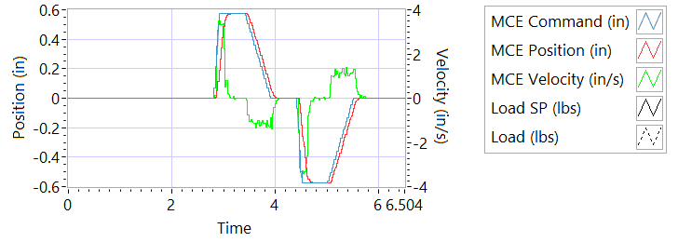

Figure - Results for Motor Two

**Step d Extension**

|  |  |  |
| --- | --- | --- |
| Description | Actual Speed / Time | Pass/Fail |
| No Load speed is 2.7 to 3.3 in/sec | 3.1922 | True |
| Time to achieve 80% of the specified stroke (+ 0.575 ins) is 170+9/-9 ms seconds | 181 | Failed |

**Step e Retraction**

|  |  |  |
| --- | --- | --- |
| Description | Actual Speed / Time | Pass/Fail |
| No Load speed is 2.7 to 3.3 in/sec | -3.2329 | Failed |
| Time to achieve 80% of the specified stroke (- 0.575 ins) is 170+9/-9 ms seconds | 177 | True |

6.7.5.2.2 **MCE 2 - Frequency Response Test**

**Step d**

**Frequency Response**

|  |  |  |  |
| --- | --- | --- | --- |
| **Frequency** | **Phase** | **Max phase** | **Pass/Fail** |
| 0.1 Hz | -3.2544 | -20 | Pass |
| 0.5 Hz | -12.942 | -30 | Pass |
| 1 Hz | -25.092 | -40 | Pass |
| 2 Hz | -48.6 | -60 | Pass |
| 3 Hz | -72.684 | -80 | Pass |
| 4 Hz | -92.304 | -120 | Pass |
| 5 Hz | -115.56 | -180 | Pass |

6.7.5.3.1 **MCE 3 – Step Response Test**



Figure - Results for Motor Three

**Step d Extension**

|  |  |  |
| --- | --- | --- |
| Description | Actual Speed / Time | Pass/Fail |
| No Load speed is 2.7 to 3.3 in/sec | 3.0342 | True |
| Time to achieve 80% of the specified stroke (+ 0.575 ins) is 170+9/-9 ms seconds | 192 | Failed |

**Step e Retraction**

|  |  |  |
| --- | --- | --- |
| Description | Actual Speed / Time | Pass/Fail |
| No Load speed is 2.7 to 3.3 in/sec | -3.0436 | Failed |
| Time to achieve 80% of the specified stroke (+ 0.575 ins) is 170+9/-9 ms seconds | 190 | Failed |

6.7.5.3.2 **MCE 3 Frequency Response Test**

**Step d**

|  |  |  |  |
| --- | --- | --- | --- |
| **Frequency** | **Phase** | **Max phase** | **Pass/Fail** |
| 0.1 Hz | -3.1536 | -20 | True |
| 0.5 Hz | -12.042 | -30 | True |
| 1 Hz | -24.192 | -40 | True |
| 2 Hz | -47.52 | -60 | True |
| 3 Hz | -70.848 | -80 | True |
| 4 Hz | -92.304 | -120 | True |
| 5 Hz | -114.12 | -180 | True |

6.7.6 **Performance Test – Loaded Operation**

6.7.6.1 **Step and Frequency Response Test - Loaded**

6.7.6.1.1 **MCE1 – Step Response Test**

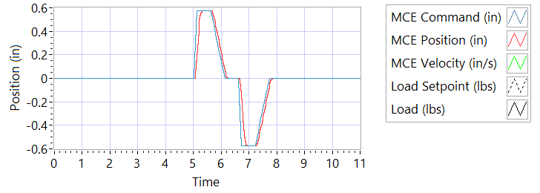

Figure - Results for Motor One Loaded

Step response Test

**Step j – 225 lbf tension**

|  |  |  |
| --- | --- | --- |
| Description | Actual Value | Pass/Fail |
| speed between 2.07 and 2.53 in/sec | 3.2696 | True |
| Time to achieve 80% of the specified stroke (+ 0.575 ins) is 170 +9/-9 ms | 185 | Failed |

**Step k – 225 lbf tension**

|  |  |  |
| --- | --- | --- |
| Description | Actual Value | Pass/Fail |
| speed between 2.07 and 2.53 in/sec | -2.8557 | Failed |
| Time to achieve 80% of the specified stroke (- 0.575 ins) is 170 +9/-9 ms | 203 | Failed |

**Step n – 225 lbf compression**

|  |  |  |
| --- | --- | --- |
| Description | Actual Value | Pass/Fail |
| speed between 2.07 and 2.53 in/sec | 2.8171 | True |
| Time to achieve 80% of the specified stroke (+ 0.575 ins) is 170 +9/-9 ms | 208 | Failed |

**Step o – 225 lbf compression**

|  |  |  |
| --- | --- | --- |
| Description | Actual Value | Pass/Fail |
| speed between 2.07 and 2.53 in/sec | -3.2319 | Failed |
| Time to achieve 80% of the specified stroke (- 0.575 ins) is 170 +9/-9 ms | 183 | Failed |

6.7.6.1.2 **MCE 1 – Frequency Response Test**

**Step d – 225 lbf Tension**

|  |  |  |  |
| --- | --- | --- | --- |
| **Frequency** | **Phase** | **Max phase** | **Pass/Fail** |
| 0.1 HZ | -4.158 | -20 | Pass |
| 0.5 HZ | -13.356 | -30 | Pass |
| 1 HZ | -25.884 | -40 | Pass |
| 2 HZ | -49.824 | -60 | Pass |
| 3 HZ | -71.928 | -80 | Pass |
| 4 HZ | -93.024 | -120 | Pass |
| 5 HZ | -115.56 | -180 | Pass |

**Step h – 225 lbf Compression**

|  |  |  |  |
| --- | --- | --- | --- |
| **Frequency** | **Phase** | **Max phase** | **Pass/Fail** |
| 0.1 HZ | -6.8652 | -20 | Pass |
| 0.5 HZ | -18.126 | -30 | Pass |
| 1 HZ | -30.78 | -40 | Pass |
| 2 HZ | -55.008 | -60 | Pass |
| 3 HZ | -79.596 | -80 | Pass |
| 4 HZ | -100.944 | -120 | Pass |
| 5 HZ | -127.26 | -180 | Pass |

6.7.6.1.3 **MCE 2 – Step Response Test**

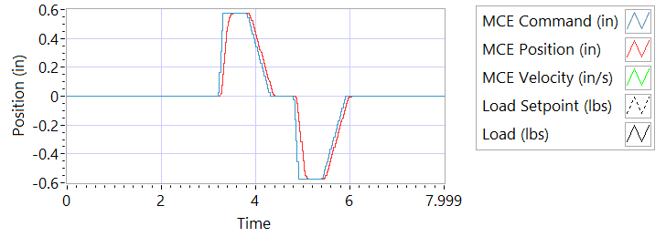

Figure - Results for Motor Two Loaded

**Step j – 225 lbf tension**

|  |  |  |
| --- | --- | --- |
| Description | Actual Value | Pass/Fail |
| speed between 2.07 and 2.53 in/sec | 3.1523 | True |
| Time to achieve 80% of the specified stroke (+ 0.575 ins) is 170 +9/-9 ms | 179 | True |

**Step k – 225 lbf tension**

|  |  |  |
| --- | --- | --- |
| Description | Actual Value | Pass/Fail |
| speed between 2.07 and 2.53 in/sec | -2.9202 | Failed |
| Time to achieve 80% of the specified stroke (- 0.575 ins) is 170 +9/-9 ms | 196 | Failed |

**Step n – 225 lbf compression**

|  |  |  |
| --- | --- | --- |
| Description | Actual Value | Pass/Fail |
| speed between 2.07 and 2.53 in/sec | 2.8222 | True |
| Time to achieve 80% of the specified stroke (+ 0.575 ins) is 170 +9/-9 ms | 206 | Failed |

**Step o – 225 lbf compression**

|  |  |  |
| --- | --- | --- |
| Description | Actual Value | Pass/Fail |
| speed between 2.07 and 2.53 in/sec | -3.0862 | Failed |
| Time to achieve 80% of the specified stroke (- 0.575 ins) is 170 +9/-9 ms | 182 | Failed |

6.7.6.1.4 **MCE 2 – Frequency response Test**

**Step d – 225 lbf Tension**

|  |  |  |  |
| --- | --- | --- | --- |
| **Frequency** | **Phase** | **Max phase** | **Pass/Fail** |
| 0.1 HZ | -3.3624 | -20 | True |
| 0.5 HZ | -13.41 | -30 | True |
| 1 HZ | -25.2 | -40 | True |
| 2 HZ | -48.6 | -60 | True |
| 3 HZ | -71.388 | -80 | True |
| 4 HZ | -93.456 | -120 | True |
| 5 HZ | -113.94 | -180 | True |

**Step h – 225 lbf Compression**

|  |  |  |  |
| --- | --- | --- | --- |
| **Frequency** | **Phase** | **Max phase** | **Pass/Fail** |
| 0.1 HZ | -7.9596 | -20 | True |
| 0.5 HZ | -18.414 | -30 | True |
| 1 HZ | -31.644 | -40 | True |
| 2 HZ | -56.376 | -60 | True |
| 3 HZ | -81.108 | -80 | Failed |
| 4 HZ | -104.112 | -120 | True |
| 5 HZ | -128.16 | -180 | True |

6.7.6.1.5 **MCE 3 – Step Response Test**



Figure - Results for Motor Three

**Step j – 225 lbf tension**

|  |  |  |
| --- | --- | --- |
| Description | Actual Value | Pass/Fail |
| speed between 2.07 and 2.53 in/sec | 3.0588 | True |
| Time to achieve 80% of the specified stroke (+ 0.575 ins) is 170 +9/-9 ms | 202 | Failed |

**Step k – 225 lbf tension**

|  |  |  |
| --- | --- | --- |
| Description | Actual Value | Pass/Fail |
| speed between 2.07 and 2.53 in/sec | -2.7435 | Failed |
| Time to achieve 80% of the specified stroke (- 0.575 ins) is 170 +9/-9 ms | 220 | Failed |

**Step n – 225 lbf compression**

|  |  |  |
| --- | --- | --- |
| Description | Actual Value | Pass/Fail |
| speed between 2.07 and 2.53 in/sec | 2.6361 | Failed |
| Time to achieve 80% of the specified stroke (+ 0.575 ins) is 170 +9/-9 ms | 216 | Failed |

**Step o – 225 lbf compression**

|  |  |  |
| --- | --- | --- |
| Description | Actual Value | Pass/Fail |
| speed between 2.07 and 2.53 in/sec | -2.9517 | Failed |
| Time to achieve 80% of the specified stroke (- 0.575 ins) is 170 +9/-9 ms | 191 | Failed |

6.7.6.1.6 **MCE 3 – Frequency Response Test**

**Step d – 225 lbf Tension**

|  |  |  |  |
| --- | --- | --- | --- |
| **Frequency** | **Phase** | **Max phase** | **Pass/Fail** |
| 0.1 HZ | -3.1968 | -20 | True |
| 0.5 HZ | -13.464 | -30 | True |
| 1 HZ | -24.984 | -40 | True |
| 2 HZ | -48.24 | -60 | True |
| 3 HZ | -71.928 | -80 | True |
| 4 HZ | -94.896 | -120 | True |
| 5 HZ | -115.38 | -180 | True |

**Step h – 225 lbf Compression**

|  |  |  |  |
| --- | --- | --- | --- |
| **Frequency** | **Phase** | **Max phase** | **Pass/Fail** |
| 0.1 HZ | -7.7004 | -20 | True |
| 0.5 HZ | -18.216 | -30 | True |
| 1 HZ | -31.356 | -40 | True |
| 2 HZ | -55.872 | -60 | True |
| 3 HZ | -79.488 | -80 | True |
| 4 HZ | -104.112 | -120 | True |
| 5 HZ | -126.54 | -180 | True |

**6.7.7 Holding Load Test**

6.7.7.1 Brake OFF, LEMA Output Locked

|  |  |  |  |  |
| --- | --- | --- | --- | --- |
| MCE | Expected Output force, lbf | Actual Output force, lbf | Output force, Pass/Fail | Position feedback signals (all sensors) Pass/Fail |
| MCE 1, 6.7.8.1.1 step i – extend 0.2 in | 325-800 lbf | -286.8691 | Failed | RESULTS |
| MCE 1, 6.7.8.1.1 step k - retract 0.2 in | 325-800 lbf | 306.4644 | Failed | RESULTS |
| MCE 2, m step i – extend 0.2 in | 325-800 lbf | -249.2031 | Failed | RESULTS |
| MCE 2, m step k - retract 0.2 in | 325-800 lbf | 277.3048 | Failed | RESULTS |
| MCE 3 m step i – extend 0.2 in | 325-800 lbf | -248.6431 | Failed | RESULTS |
| MCE 3 m step k - retract 0.2 in | 325-800 lbf | 278.7893 | Failed | RESULTS |

**6.7.7.2 Brake ON, LEMA Output Free**

|  |  |  |  |  |
| --- | --- | --- | --- | --- |
| MCE | 12.6 +- TBD Amps for 3-5 sec | Current Pass/Fail | Position feedback | Position Feedback Pass/Fail |
| MCE 1, 6.7.8.2.1 step I – extend 0.2 in | 5.9993 | True | -0.547 | Pass |
| MCE 1, 6.7.8.2.1 step k - retract 0.2 in | -6.0017 | Failed | -0.5478 | Pass |
| MCE 2, 6.7.8.2.2 6.7.8.2.3 step i – extend 0.2 in | 5.9985 | True | -0.5556 | Failed |
| MCE 2, m step k - retract 0.2 in | -5.9951 | True | -0.5572 | Failed |
| MCE 3 m step i– extend 0.2 in | 5.9908 | True | -0.5651 | Failed |
| MCE 3 m step k - retract 0.2 in | -5.9961 | True | -0.5666 | Failed |

**6.7.7.3 Brake Release test**

**Step d –** LEMA reaches commanded position

|  |  |  |  |  |
| --- | --- | --- | --- | --- |
| Description | Expected | Tolerance | Position | Pass/Fail |
| MCE1 /Motor 1 | 0.2 |  | 0.1802 | Pass |
| MCE2 /Motor 2 | 0.2 |  | 0.1854 | Pass |
| MCE3 /Motor 3 | 0.2 |  | 0.1881 | Pass |

6.7.8 **Backlash**

6.7.8.1 **Simplex Brake 1 – ON; Duplex brake 2 – OFF**

|  |  |  |  |
| --- | --- | --- | --- |
| Load (lbf) | Backlash (ins) | | Pass/Fail |
| Step **Error! Reference source not found.** +/- 35 lbf tension (motor 2 and motor 3 ZERO position) |  | |  |
| Step e +/- 25 lbf compression  (motor 2 and motor 3 ZERO position) |  | |  |
| Step **Error! Reference source not found.**, Total backlash | New units: 0.0144 ins  In Service Units: 0.019 ins | |  |
| All channels feedback signals remain within allowable limits | Allowable limit | Actual Value | Pass/Fail |
| Motor 1 |  |  |  |
| Motor 2 |  |  |  |
| Motor 3 |  |  |  |
| M1 |  |  |  |
| M2 |  |  |  |
| M3 |  |  |  |

**Error! Reference source not found.** **Simplex Brake 1 – OFF; Duplex Brake 2 – ON**

|  |  |  |
| --- | --- | --- |
| Load (lbf) | Backlash (ins) | Pass/Fail |
| Step **Error! Reference source not found.** +/- 35 lbf tension, +/- 25 lbf compression (motor 1 ZERO position) |  |  |
| Step **Error! Reference source not found.**, Total backlash | New units: 0.0144 ins  In Service Units: 0.019 ins |  |
| All channels feedback signals (Motor 1, Motor 2, Motor 3, M1, M2 and M3 remain within allowable limits |  |  |

**Error! Reference source not found.** **Both Brakes OFF**

|  |  |  |
| --- | --- | --- |
| Load (lbf) | Backlash (ins) | Pass/Fail |
| Step **Error! Reference source not found.** +/- 35 lbf tension, +/- 25 lbf compression (motor 1 and motor 2 holding ZERO position) |  |  |
| Step **Error! Reference source not found.**, Total backlash | New units: 0.0144 ins  In Service Units: 0.019 ins |  |
| All channels feedback signals (Motor 1, Motor 2, Motor 3, M1, M2 and M3 remain within allowable limits |  |  |